News
03.08.2017

MINISTRY OF FINANCE WILL BEGIN TO BUY CURRENCY FROM AUGUST.
Ministry of finance will channel 46,7 billion rubles on purchase to exchange on domestic currency market. Purchases will continue from August 7 till September 1. The currency will be bought for the reasons of actual deviation of oil and gas revenues as for year –end 2017, that were carried out in the previous month, it was due to the high dollar’s exchange rate. The US dollar was growing against the background of different indicators: runover of gas, export turnover of oil products.
The Central Bank of the Russian Federation will be involved to buy currency. Operations will take place every day during the specified period Of MOEX tender.
07.08.2017

RATES OF BANK MORTGAGES STILL TUMBLE.
The Bank of Russian Federation claimed about the reduction of rates under the real estate credits up to minimal historical values, according to the “Commercant»( «Коммерсанть»). Rates of interest on mortgage averaged 11,11% per annum, it was given on the regulator’s web site. Moreover, there is an information on the mortgage loan volume for the first half of this year and past, that is 16 % higher than previous year. In the message of regulator it was mentioned that banks provided 423,5 thousand mortgage products worth about 773 billion rubles. The percentage of delay in payments ( arrears) was -1,5 %, which is a low mark in the equivalent (71,6 billion).
The Ministry of Economy represented by Maksim Oreshkin and the director of AHML Aleksandr Plutnik continue talking about the reduction of mortgage rates.
In Oreshkin’s opinion, the level of rates is expected to be 8-9%, while the director of AHML says about the reduction to 6-7 % by the next year.
25 May 2017
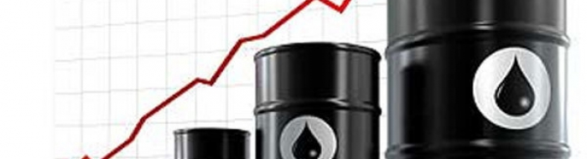
WILL THE AGREEMENT OF THE OPEC (Organization of Petroleum-Exporting Countries) COUNTRIES ON THE MORATORIUM ON OIL BE EXTENDED?
So, the meeting of the OPEC countries is on the agenda. Iraq expressed its opinion on the extension of the production restriction for another nine months. Journalists got to learn it from the Minister Jabbar al-Laibi. It also became known that Iran expects from Moscow barter for food and expects the nearest supplies.
As our analysts noted earlier oil will react instantly. At the moment, she updated her lows to $53.40 per barrel, after that it rose again, then fell again.
At that very moment the agreement has not been signed yet and for this reason the market is feverish. According to the Finance Minister Anton Siluanov, the moratorium will positively affect both us and the OPEC countries due to price conjecture.
«Convenience and comfort of your car»
10 May 2017
Honorable residents of the residential compound!
We invite you to the Management Companyoffice, where we will tell you how to get a temporary place in a roofed and guarded garage complex.

Services are provided according to the company's price list.
On any questions we are waiting for you every day from 10 am to 9 pm.

